Homework Assignment 1

Zach Kushnir

1- A new example of a regression problem could be assigning a salary to a new worker. Using a list of previous employees with their qualifications/experiences as input and salary as output you can predict the salary of a new worker given their qualifications/experiences.

1. Features, x, can be qualifications such as degree, gpa, and previous work experience as well as the type of job they are getting.
2. The label, y, would be the salary output.
3. I would collect data from previous and current employees to create the model.
4. This problem may be challenging with not enough training data which would result in underfitting. Additionally, it would be best to have many features for an accurate salary estimation and it could be difficult to quantize certain aspects of a person's qualifications.

2- A new example of a classification problem could be labeling pictures of animals with what animal they are. By learning the pattern of pixels in an image you can recognize a similar pattern in a new image to depict which animal it is.

1. Features, x, would be an array of image pixels.
2. The label, y, would be the animal type.
3. I would collect data from a pool of existing images of various animals labeled with their animal type.
4. The problem could turn out to be challenging if the orientation of the animal causes the learning algorithm to misinterpret which animal it is.

3-Basic operations

1. Code in MATLAB file
2. Code in MATLAB file
3. Yes, the histogram for x does look like a gaussian distribution and the histogram for z does look like a uniform distribution.

Images:

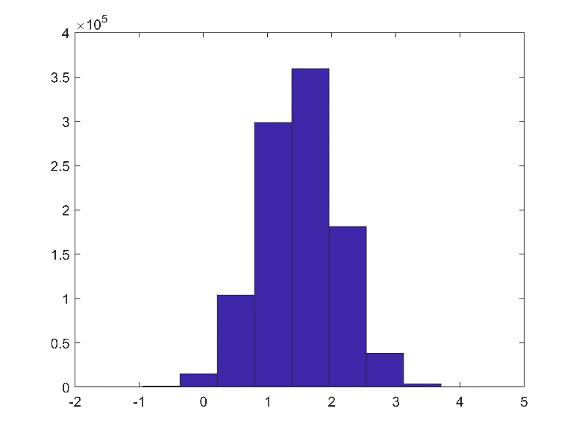

ps1-3-c-1.png

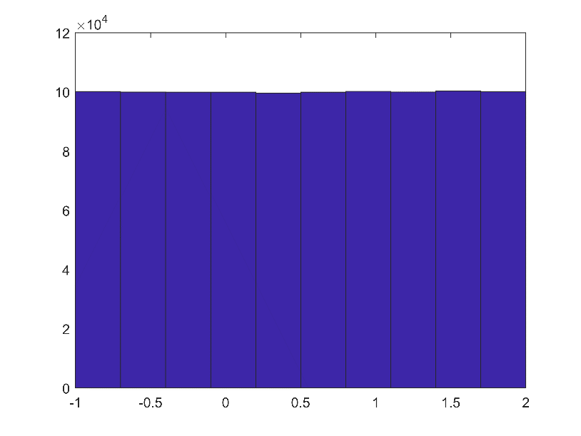

ps1-3-c-2.png

1. Elapsed time is 0.017314 seconds.
2. Elapsed time is 0.001558 seconds. It is much faster to add a constant to the vector without using a loop.
3. There are 374479 elements. There is no difference in the number of elements after running the code again. This is because the vector does not change after the random number generator is initialized when first opening MATLAB.

4- Linear Algebra

1. Code in MATLAB file
2. x = 0.3, y = 0.4, z = 0
3. Code in MATLAB file

5- Function

Function input:

A =

     2     1     3

     2     6     8

     6     8    18

Function output:

ans =

    44   101   397

Function input:

b =

     1

     3

     5

Function output:

ans =

    35